浙 江 财 经 大 学

实 验（实训）报 告

项 目 名 称 面板数据模型
所属课程名称 计量经济学（双语）
项 目 类 型 综合性实验
实验(实训)日期 2025年05月26日

班 级 22应用统计
学 号 220110780419
姓 名 刘晓亮
指导教师 倪伟才

浙江财经大学教务处制

一、实验（实训）概述：
【目的及要求】
目的: 掌握面板数据的固定效应模型，随机效应模型的估计。对于面板数据的3种估计方法：POOLED OLS,FE,RE，如何在其中的两种方法中进行选择。主要掌握LMtest和Hausman test.
要求: 掌握固定效应模型，随机效应模型,按具体的题目要求完成实验报告,并及时上传到彩云系统。
【基本原理】
GLS, LM test, Hausman test
【实施环境】（使用的材料、设备、软件）
STATA软件
二、实验（实训）内容：
【项目内容】
面板数据模型
【方案设计】
[题目来自《Introductory Econometrics A Modern Approchg》J.M.Wooldridge, chapter 14 ]
【实验（实训）过程】（步骤、记录、数据、程序等）

附后
【结论】（结果、分析）
附后
三、指导教师评语及成绩：
评语：流程完整，结果正确

成绩： 优秀 指导教师签名：倪伟才
批阅日期：25年 06 月

实验八报告
面板数据模型（综合性实验）

实验题目一：
[abstracted from《Introductory Econometrics A Modern Approchg》J.M.Wooldridge, chapter 14 C14. 9]
Use the data in wagepan.dta for this exercise.
(i)Estimate the model
by pooled OLS, and report the estimates and standard errors in the usual form.
(ii)Estimate the model from part (i) by random effects (thinking that 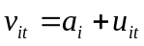).How do the RE and pooled OLS estimators of 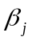 compare?
(iii) Are the RE and pooled OLS standard errors the same? Which ones are more reliable, and why?

实验题目二：
[abstracted from《Introductory Econometrics A Modern Approach》(3rdJ.M.Wooldridge, chapter 14 C14. 10]
Use the data in airfare.dta for this exercise. We are interested in estimating the model
Where 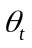 means that we allow for different year intercepts.[Hint: y98,y99,y00]
(i)Estimate the above equation by pooled OLS, being sure to include year dummies. If 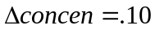,what is the estimated percentage increase in fare?
(ii)What is the usual OLS 95% confidence interval for 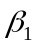? Why is it probably not reliable? If you have access to a statistical package that computes fully robust standard error, find the fully robust 95% CI for . Compare it to the usual CI and comment.
(iii)Describe what is happening with the quadratic in log(dist). In particular, for what values of dist does the relationship between log(fare) and dist become positive? [Hint:: First figure out the turning point value for log(dist), and exponentiate .]Is the turning point outside the range of the data?
(iv)Now estimate the equation using random effects. How does the estimate of change?
(v) Now estimate the equation using fixed effects. What is the FE estimate of ? Why is it fairly similar to the RE estimate? [Hint:: What is for RE estimation?]
实验题目一分析报告：
(i)
// 1
use "WAGEPAN.DTA",clear
reg lwage educ black hisp
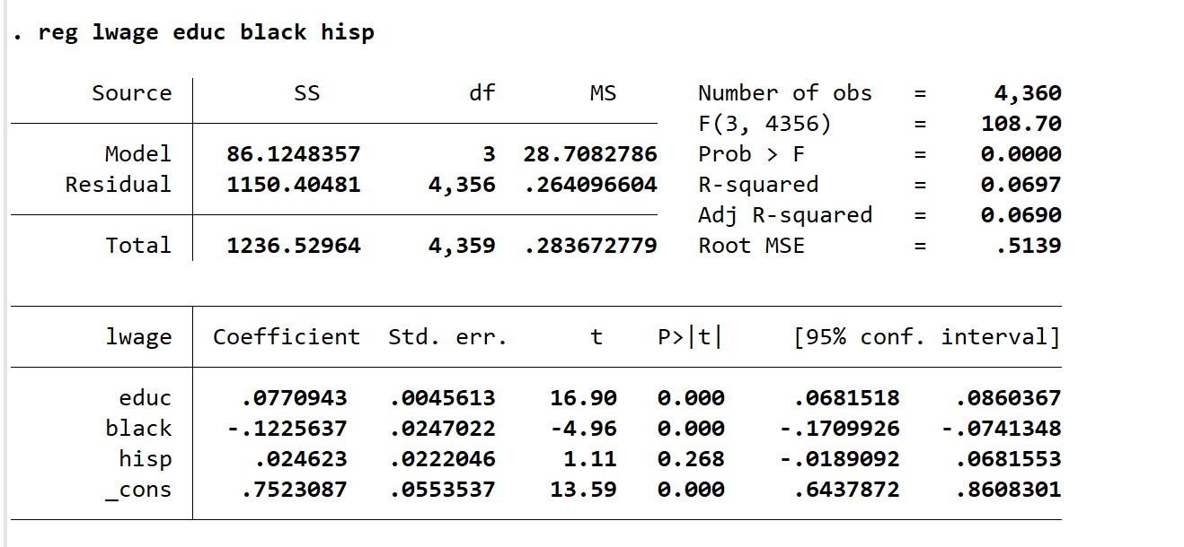
(ii)
xtreg lwage educ black hisp,re
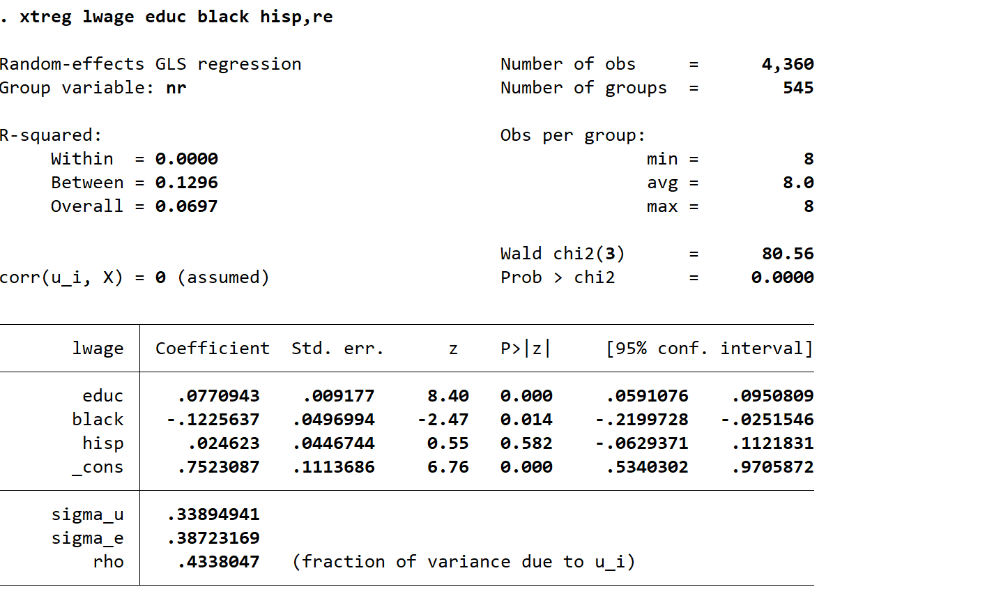
RE 模型与 pooled OLS 估计方法所有变量前系数相等。

(iii)
标准误不同。我们可以用LM Test检验哪一个估计方法更好
xttest0
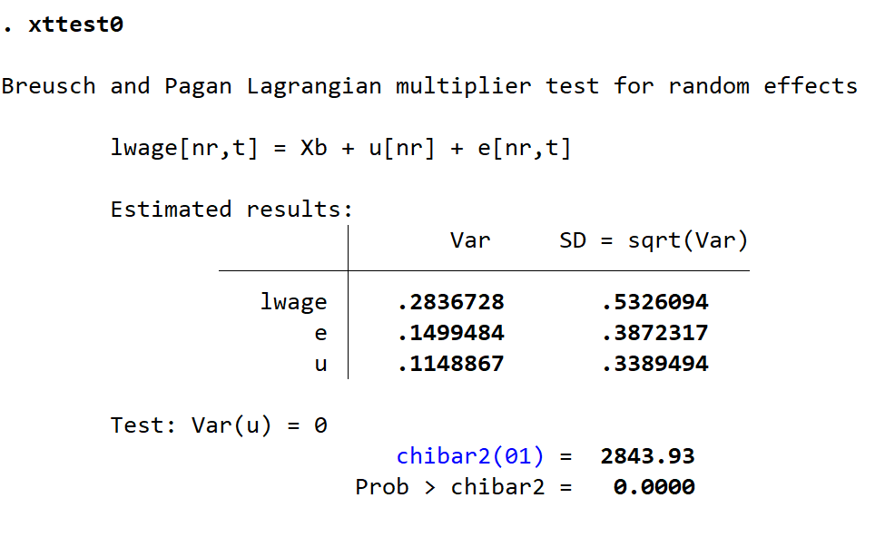
拒绝原假设

实验题目二分析报告：
(i)
use "airfare.dta",clear
reg lfare concen ldist ldistsq y98 y99 y00
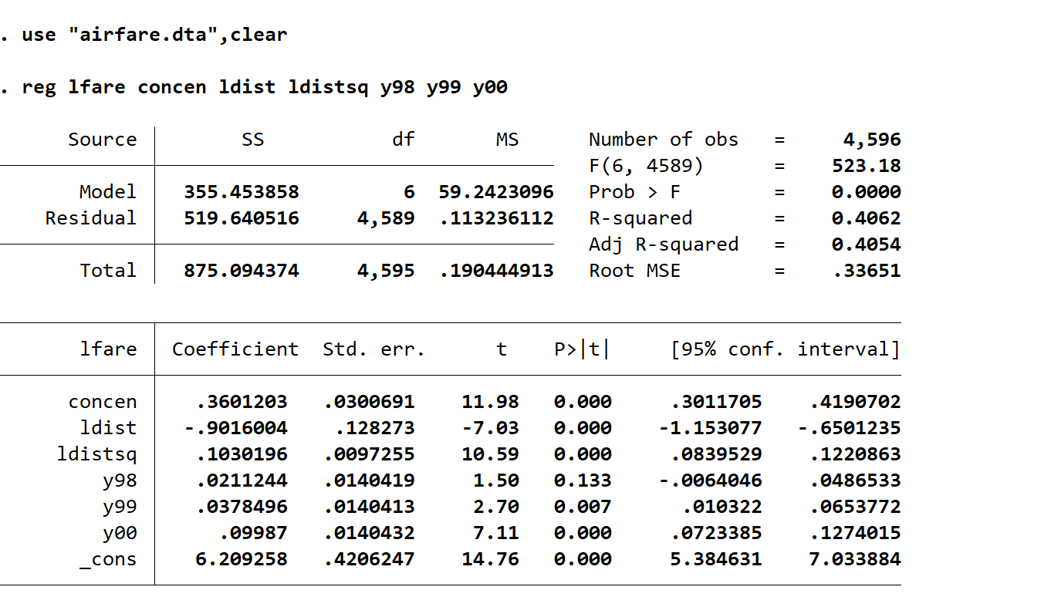
β 1=0.36，如果△concen =.10，那么△log（fare）=0.36*0.10=0.036，即票价提高
3.6%

(ii)
reg lfare concen ldist ldistsq y98 y99 y00, robust
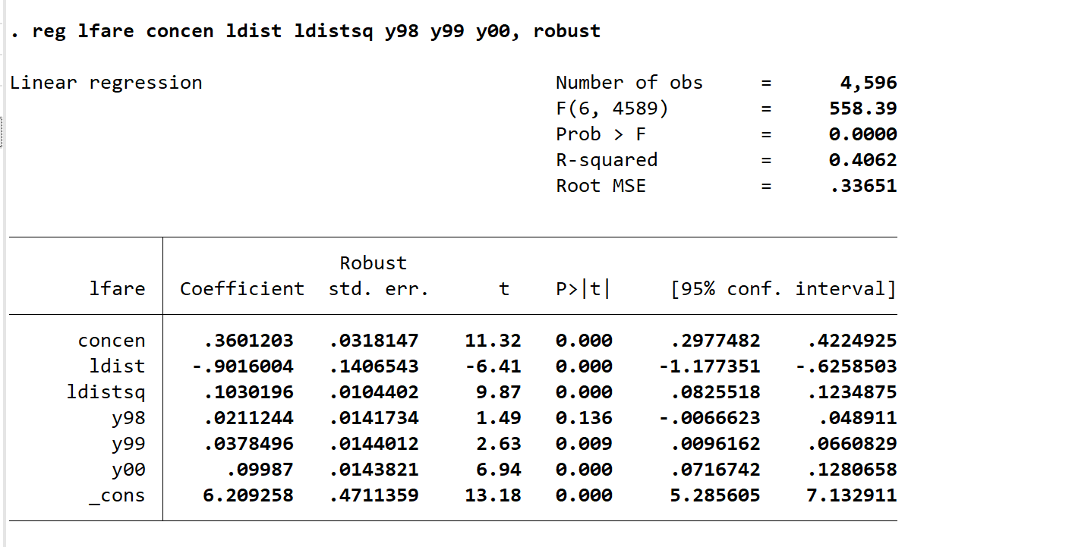
OLS 95%置信区间不可靠的原因是可能回归方程中误差项会存在异方差或解释变量与误差项不自相关

(iii)
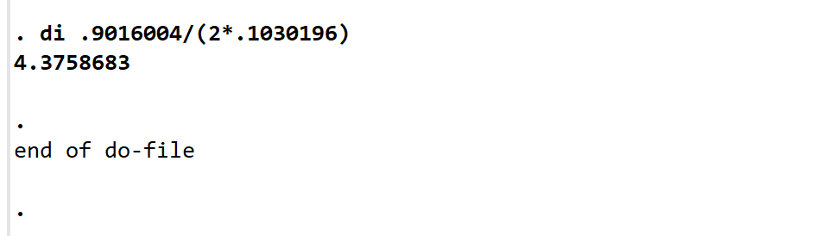
Log(fare)和log(dist)之间是开口向上的二次型，当log(dist）小于4.37时，log(fare)随之增大而减小。
(iv)
xtreg lfare concen ldist ldistsq y00 y99 y98,re
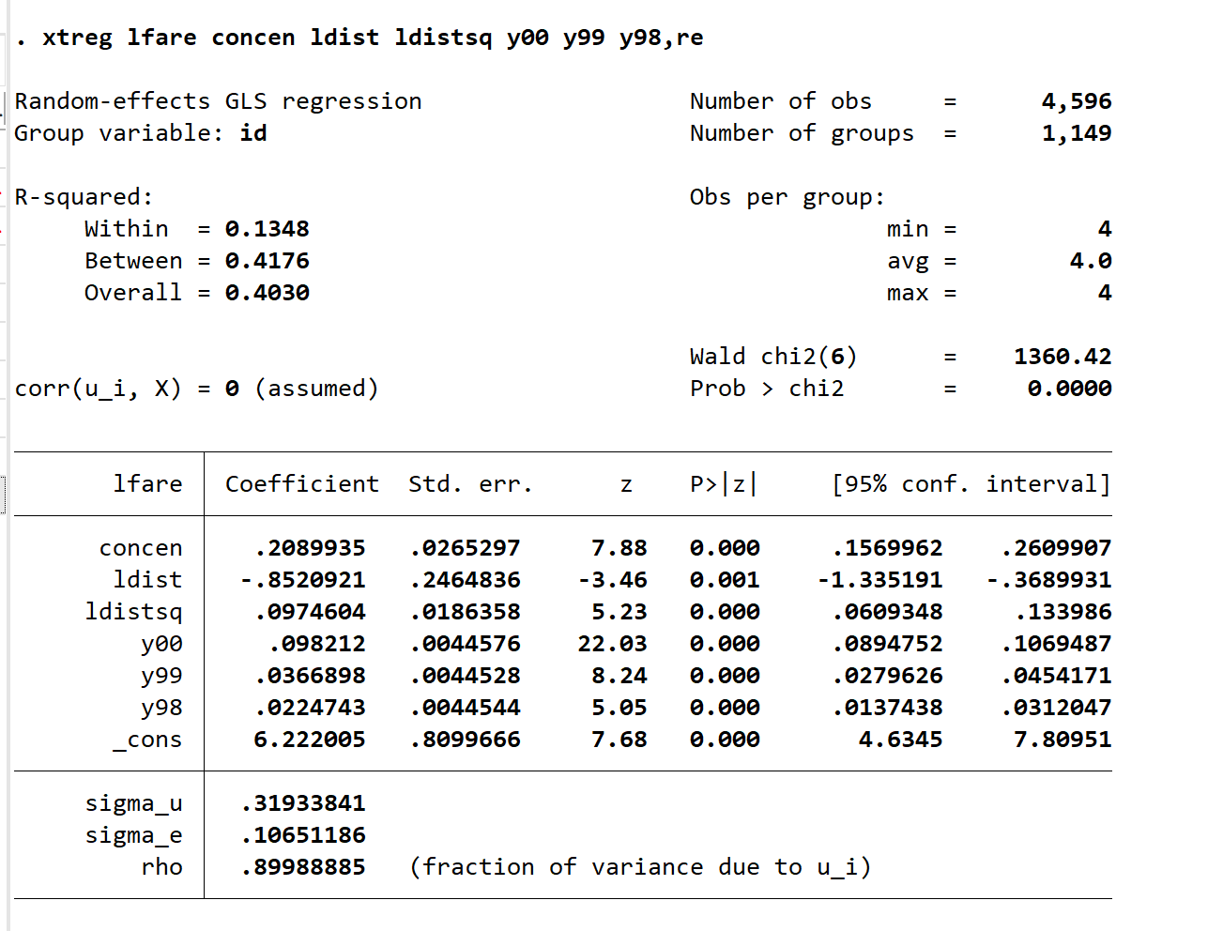
beta发生了改变，但是显著性未发生改变
(v)
xtreg lfare concen ldist ldistsq y00 y99 y98,fe
est store fe
xtreg lfare concen ldist ldistsq y00 y99 y98,re theta
est store re
hausman fe re
. xtreg lfare concen ldist ldistsq y00 y99 y98,fe
note: ldist omitted because of collinearity.
note: ldistsq omitted because of collinearity.

Fixed-effects (within) regression Number of obs = 4,596
Group variable: id Number of groups = 1,149

R-squared: Obs per group:
Within = 0.1352 min = 4
Between = 0.0576 avg = 4.0
Overall = 0.0083 max = 4

F(4,3443) = 134.61
corr(u_i, Xb) = -0.2033 Prob > F = 0.0000

lfare Coefficient Std. err. t P>t [95% conf. interval]

concen .168859 .0294101 5.74 0.000 .1111959 .226522
ldist 0 (omitted)
ldistsq 0 (omitted)
y00 .0977717 .0044555 21.94 0.000 .089036 .1065073
y99 .0363819 .0044495 8.18 0.000 .0276579 .0451058
y98 .0228328 .0044515 5.13 0.000 .0141048 .0315607
_cons 4.953331 .0182869 270.87 0.000 4.917476 4.989185

sigma_u .43389176
sigma_e .10651186
rho .94316439 (fraction of variance due to u_i)

F test that all u_i=0: F(1148, 3443) = 60.52 Prob > F = 0.0000

. xtreg lfare concen ldist ldistsq y00 y99 y98,re theta

Random-effects GLS regression Number of obs = 4,596
Group variable: id Number of groups = 1,149

R-squared: Obs per group:
Within = 0.1348 min = 4
Between = 0.4176 avg = 4.0
Overall = 0.4030 max = 4

Wald chi2(6) = 1360.42
corr(u_i, X) = 0 (assumed) Prob > chi2 = 0.0000
theta = .83550226

lfare Coefficient Std. err. z P>z [95% conf. interval]

concen .2089935 .0265297 7.88 0.000 .1569962 .2609907
ldist -.8520921 .2464836 -3.46 0.001 -1.335191 -.3689931
ldistsq .0974604 .0186358 5.23 0.000 .0609348 .133986
y00 .098212 .0044576 22.03 0.000 .0894752 .1069487
y99 .0366898 .0044528 8.24 0.000 .0279626 .0454171
y98 .0224743 .0044544 5.05 0.000 .0137438 .0312047
_cons 6.222005 .8099666 7.68 0.000 4.6345 7.80951

sigma_u .31933841
sigma_e .10651186
rho .89988885 (fraction of variance due to u_i)
hausman fe re

Coefficients ----
(b) (B) (b-B) sqrt(diag(V_b V_B))
fe re Difference Std. err.

concen .168859 .2089935 -.0401345 .0126937
y00 .0977717 .098212 -.0004403 .
y99 .0363819 .0366898 -.000308 .
y98 .0228328 .0224743 .0003585 .

b = Consistent under H0 and Ha; obtained from xtreg.
B = Inconsistent under Ha, efficient under H0; obtained from xtreg.

Test of H0: Difference in coefficients not systematic

chi2(4) = (b-B)'[(V_b-V_B)^(-1)](b-B)
= 10.00
Prob > chi2 = 0.0405
(V_b-V_B is not positive definite)

分析：RE 模型中的2=0.8355，接近于1，所以FE 与 RE 估计值接近，因为chi2（4）=10>0，所以选择FE。

